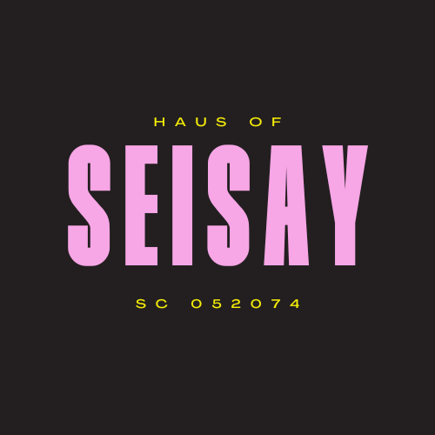

Progress and Impact Report: Haus of Seisay Hairdressing Academy Programme

Overview
The programme initiative of the Haus of Seisay Hairdressing Academy aimed to provide care-experienced young people with a pathway toward skills development, personal growth, and career opportunities. Over the eight-week course, the academy employed a holistic and highly supportive approach, which has shown transformative results for participants, fostering a renewed sense of hope, skill acquisition, and positive personal and professional growth.

Key Achievements
- Tailored Learning Approach
  - The academy implemented a one-on-one and small-group model, allowing for a personalized and responsive approach. Each participant received individualized attention, which enabled a supportive environment addressing their specific needs. This method facilitated the successful completion of the course by all students, each earning an SVQ qualification in hairdressing.
- Expanded Networks and Visibility
  - The programme has effectively raised the profile of the Haus of Seisay, increasing visibility and strengthening partnerships within the community. Enhanced connections with local organizations, statutory agencies, and private sector entities have broadened future opportunities for participants, enriching the academy's resources and establishing support pathways for subsequent cohorts.
- Cultivation of Hope and Confidence
  - The programme was instrumental in building confidence and a sense of optimism among participants. Weekly observations documented measurable improvements in self-assurance and mutual support within the group, contributing to meaningful friendships and fostering a supportive peer network beyond the initial course.
- Sense of Belonging and Safe Learning Environment
  - Participants emphasized the importance of the academy’s safe, non-judgmental environment. This nurturing space promoted empathy, allowed participants to share their experiences openly, and helped mitigate the stigma often associated with care-experienced backgrounds, enabling a positive and inclusive learning atmosphere.
- Ownership and Pride
  - A co-production approach encouraged participants to engage actively in their learning journey. Many expressed a profound sense of ownership, pride, and accomplishment.
- Holistic Support and Improved Life Areas
  - The academy's ongoing assessments indicated a broad range of positive life improvements among participants, including enhanced mental health, greater use of support services, increased self-esteem, a reduction in harmful behaviours, and strengthened resilience. Peer support and focus group activities were key in promoting this well-rounded personal development.

Learning from the Programme
- Crisis Element Incorporation
  - Through this programme, a critical need was identified for immediate crisis support to assist participants during periods of acute personal challenge. Incorporating this element would provide participants with timely assistance, enabling them to stay engaged with the program and maintain progress even in adverse circumstances.

Next Steps
- Continued Support
  - Graduates of the programme will continue to receive support from Haus of Seisay and be linked to external organizations to ensure consistent assistance as they progress towards positive career and personal goals.
- Diverse Paths
  - The varied pathways chosen by participants following course completion underscore the impact of the program. Graduates are pursuing further education, careers in hairdressing and barbering, and other vocational aspirations, demonstrating the program's adaptability to each participant’s individual goals.

Quotes from Participants
- “This has given hope for the future.”
- “This has been way better than school, Haus Of Seisay understand me and my background way more than a normal teacher would.”

This progress and impact report affirms the Haus of Seisay Hairdressing Academy programme as a valuable and transformative program. Through strategic support, individualized learning, and a nurturing environment, the initiative successfully fostered empowerment, confidence, and resilience among care-experienced young people, laying the groundwork for sustained personal and professional growth.

